**Project BR04D$W0RD**

**Administrative Manual**

------------------------------------------------------------------------------------------------------------------------------------------

**Table of Contents**

Intended Use

Non-administrative use

* Calendar Screen

Administrative Use

* Login Screen
* Calendar Screen
* Create Reservation Screen
* Edit Reservation Screen
* Delete Reservation

------------------------------------------------------------------------------------------------------------------------------------------

**Intended Use**

This application is intended to be a scheduling application for a group of people needing the same space in order to ensure they are not reserving space on top of one another. The output of this application will be a two-week calendar that will show all current reservations from the current week and the week after.

**Non-administrative use**

Users that do not possess the login for the application will only be shown the calendar with the reservations. They will see the screen below, which shows them the different reservations that have been booked through the application as well as which team has the time booked. They will be able to access the log in screen as well as previous and next weeks to view booked times.

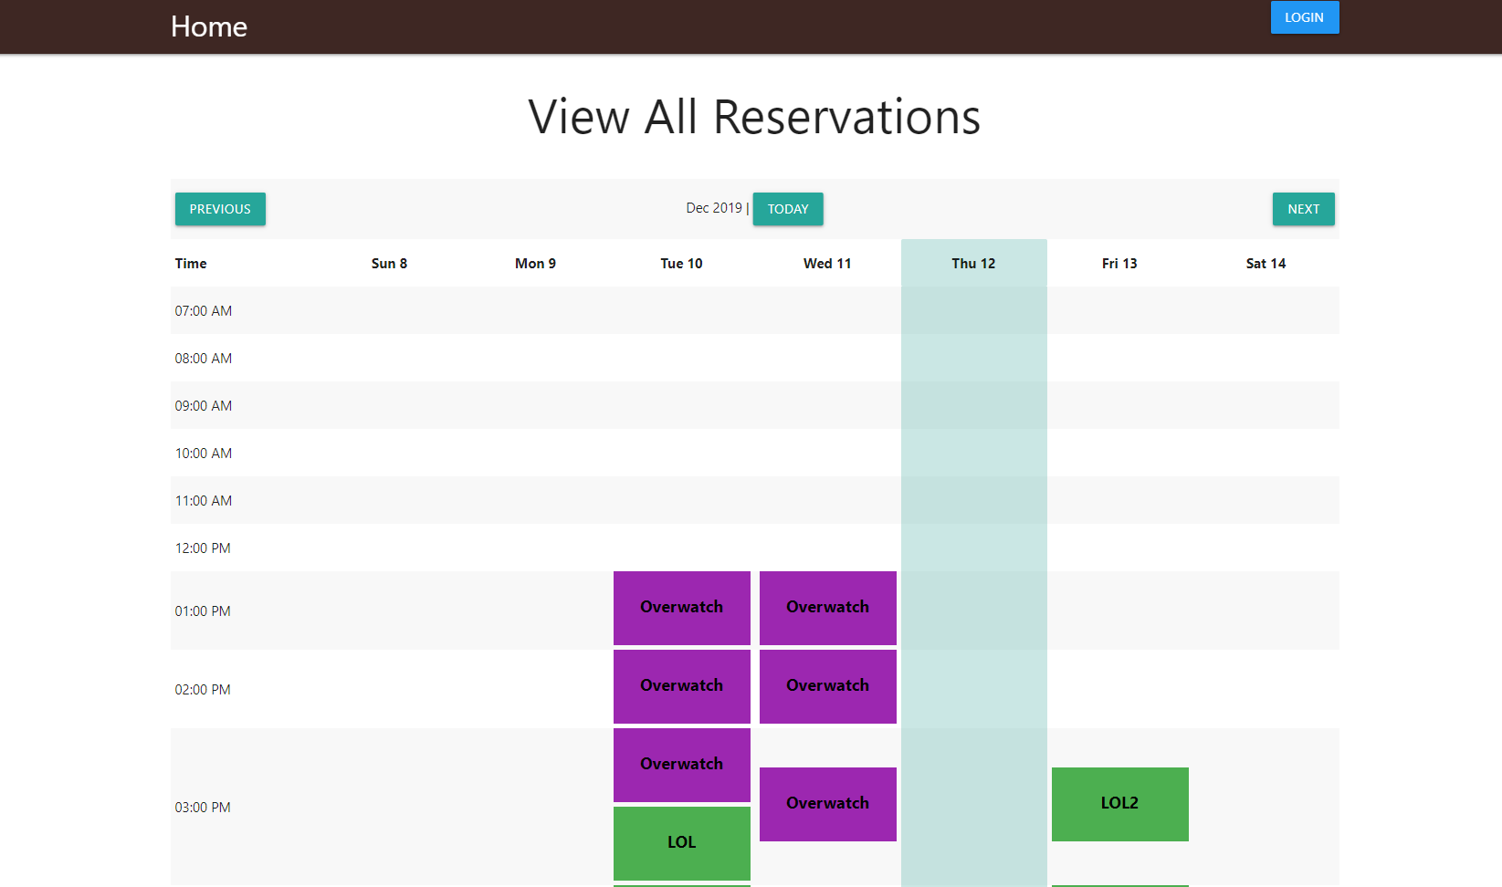

**Administrative Use**

**Login Screen**

Here users will log in. At the time of deployment, there is only one login which is given to select users.

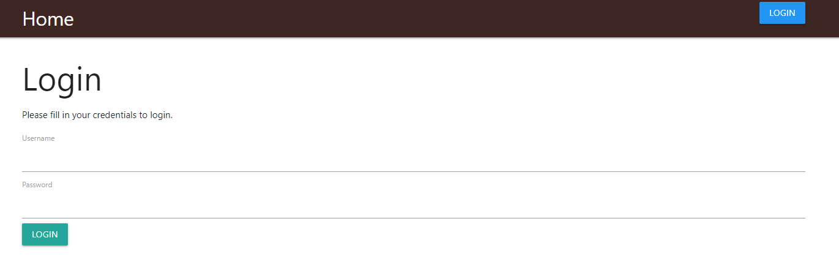

**Calendar Screen**

This screen will show the different reservations that have been booked through the application as well as which team has the time booked. They will also be able to access the previous and next weeks to view booked times. The administrative user will see buttons to create a reservation and to log out at the top of the screen. Clicking on a reservation will allow for edit and delete options to appear pertaining to that particular reservation.

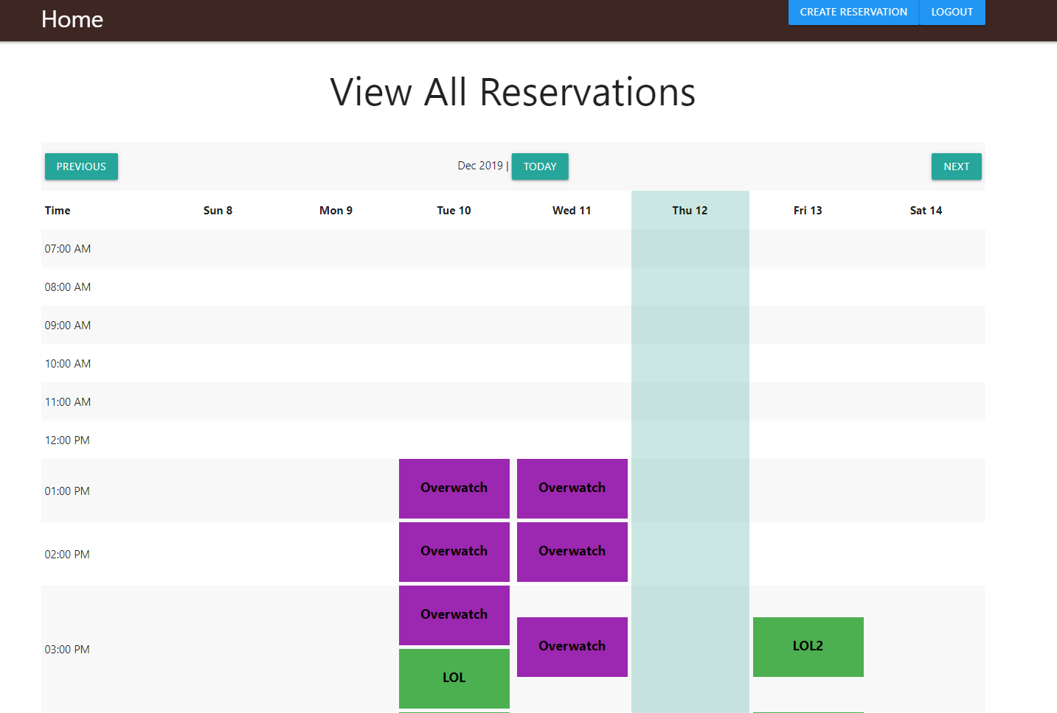

**Create Reservation Screen**

After clicking on the create reservation button on the calendar, a form to create the reservation appears as shown below.

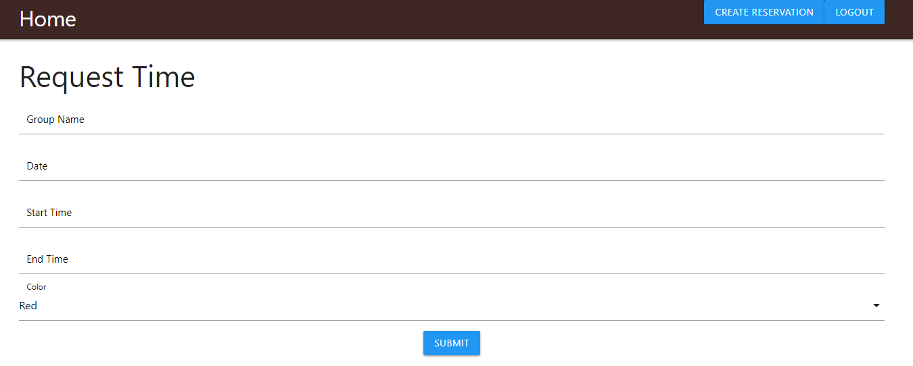

**Edit Reservation Screen**

After click on the edit reservation button on the calendar screen, the same form that appears for the create reservation screen show up populated with the current booking information. From here, the user can update the information and resubmit to update the reservation.

**Delete Reservation**

Although this is not a screen, it is important functionality. To delete a reservation, click on the reservation and select the delete button. It will prompt the user to confirm the deletion, then upon approval will delete the reservation and update the calendar.

